II B. Tech. II Semester Supplementary Examinations – October, 2023

OPERATING SYSTEMS

Time: 150 Min (CSE/CSE(CS)) Max. Marks:80M

SECTION – A
Answer all Four questions 4×10M=40M

- (a) Define a critical section problem. Specify the requirements to be satisfied by the solution to the critical section problem. [R]
(b) Provide the codes correspond to entry and exit sections of a process Pi in view of Peterson solution to critical section problem.[U]
(c) Suppose the CPU on which an OS runs supports an atomic instruction fetch_and_increment as follows:

int fetch_and_increment {int *x) {
last_va lue * x ;
* x = * x + l;
return last_valu c;
Show how you can use the above instruction to implement mutual exclusion. Your solution should satisfy all three conditions of mutual exclusion, progress, and bounded waiting. [Ap]
(d) Fill in the blanks in the reader/writer code below so that it becomes a correct solution for the reader-writer problem with no starvation for either readers or writers. P and V correspond to wait and signal operations on o semaphore respectively. Assume that the semaphores SI, Cl,and XI are initial d to I and the variable n is initialized to 0.You cannot use any other semaphores or variables other than the ones shown in the code.(Write the complete Reader and Writer code in your copy, under lying the blanks filled up, no explanation is needed).[Ap]
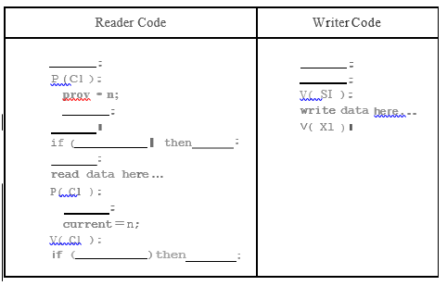

- a) Justify various types of operations performed on file system.[E]
b) In Twitter scenario, each tweet (small price of text) is stored as a small file. The size is limited to 256 bytes. Given a tweet, a user would like to take a look at the replies to the tweet, which are themselves tweets. Furthermore, it is very much possible that a tweet may be retweeted (posted again) many times. In every “retweet” a user’s friends are able to see the “retweet” (new post). Note that there are no circular dependences. It is never the case that: 1) A tweets, 2) B see it because B is A’s friend, 3) B retweets the same message and 4) A gets to see the retweet. Create an operating system for the above mentioned Twitter scenario.[Ap]
c) For the above scenario design a file system to store such tweets. How is the file system organized on the disk?[Ap]

- (a) Consider the following set of jobs. What would be the average waiting time if the following scheduling policies are used: (i) FCFS, (ii)Round Robin with time slice 2 sec? Show the Gantt chart and all calculations. Ignore the context switch time.[U]
Process Arrival Time Duration
A 0 12
B 3 7
C 6 2
D 8 5
E 8 2
F 12 12
(b) For the above data, show that Shortest-Job-First scheduling does not necessarily give the minimum waiting time for a set of jobs if the jobs arrive at different times. Do not use more than 3 jobs in your answer.[U]
(c) Create a pseudo code for (b) , for the data mentioned in (a).[Ap]
- A computer system memory has a 36-bit virtual address space with a page size of 8K, and 4 bytes per page table entry.
Answer the following.
(a) How many pages are in the virtual address space?[U]
(b) What is the maximum size of addressable physical memory in this system?[R]
(c) If the average process size is 8GB, compute the average size of page table for one-level, and two-level paging? Which is a better choice?[U]

SECTION - B
Answer all Two questions 2×20M=40M

- (a) Consider the following solution for the critical section problem.[E]
The two processes, Po and PI, share the following variables
Boolean blocked [2] /* initialized to false */
int turn; /* initialized to 0 or 1*/
The structure of the Process i (i=0 or 1) is as follows
do {
blocked [i] = true:
while (turn!=i)
{
while(blocked[l-i]); /* busy wait */
turn=i;
}
Critical section ();
blocked[i]=false;
Non-Critical section();
} while(1);
"The above solution satisfies all the necessary requirements of the critical section problem". Prove or disprove with proper justification.
(b) Consider the following program
Pl:
{
Shared int x
x=10;
while(1)
{
x=x-1;
x=x+1:
If(x!=10)
printfl?x is %d",x);
}
}

P2:
{
Shared int x
x=10;
while(1)
{
x=x-L;
x=x+l;
If(x!=l0)
printf[?« is %d",x);
}
}

Note that the scheduler in a uniprocessor system would implement pseudo parallel execution of these two concurrent processes PI and P2 by interleaving their instructions. Show a sequence of execution such that statement "x=l0" is printed. You should remember that the increment and decrement are not done atomically.[E]
(c) Consider a system which implements pre-emptive priority-based scheduler and Peterson's solution for mutual exclusion. In such a system, is it possible that a high priority process gets delayed indefinitely because of the presence of lower priority processes? Assume that no process does any I/O and there is no deadlock in the system.[E]
d) A 4-way road intersection has cars approaching it from the east, west, north and south directions. Each car is required to follow these rules at the time of intersection:
i) a car can begin to cross the intersection if some other cars immediately ahead of it and travelling in the same direction is/are crossing it.
Or
ii) a car can begin to cross the intersection if the road on its right does not have any cars waiting to cross the intersection. (Thus, a car approaching the intersection from the east should check whether any cars have already reached the intersection on the road from north and are waiting to cross).
Design a code using either semaphores or monitors for controlling traffic. [C]

- a) Explain the deadlock scenario to detect that the deadlock has been occurred?[U]
b) How can you prevent your processor without entering into deadlock state?[U]
c) Considering a system with five processes P₀ through P₄ and three resources of type A, B, C. Resource type A has 10 instances, B has 5 instances and type C has 7 instances. Suppose at time t₀ following snapshot of the system has been taken. Solve the below scenario using Bankers algorithm.[Ap]
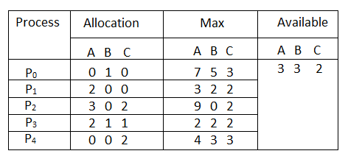
d) Create a pseudo code for the above mentioned scenario ( c). [C]

